
Personal Health, Relationship and Sex Education (PHRSE)

Year 11



Term 2: Relationships

Big Question 1: How might my beliefs and values guide my choices about relationships and family life?

Name:

Personal Health, Relationship and Sex Education (PHRSE) at Houlton School
In PHRSE lessons you will be taught about different topics that help you to develop as a person.
The three key topics in PHRSE are:
- Health and Wellbeing (E.g. Healthy living choices, mental health, managing influences, health and puberty.)
- Relationships: (E.g. Healthy and respectful relationships, consent, families and intimate relationships.)
- The Wider World: (E.g. Staying safe online, managing finances, the law, citizenship, anti-discrimination and careers.)
We will explore these as part of our learning about Fundamental British Values. These are:
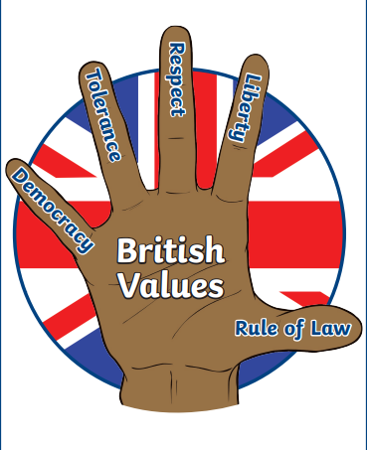

In Britain, our British values are protected by law through the Equality Act 2010. This helps to stop discrimination and ensure everyone is treated equally. There are 9 characteristics that are protected by law. These are:
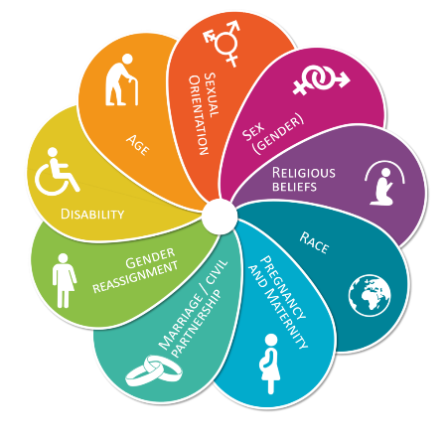

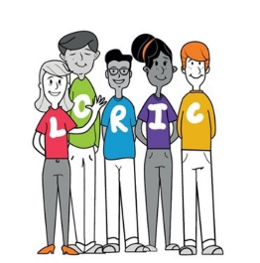
You will also have the opportunity to develop your LORIC skills through the PHRSE curriculum and use evidence of your learning to complete your PiXL assignments.
Leadership, Organisation, Resilience, Independence, Communication

  Year 11  Half Term 3 Knowledge Organiser | Big Question: How might my beliefs and values guide my choices about relationships and family life?
Key Terms
Consent: Agreement to engage in sexual activity.
Contraception: Methods to prevent pregnancy.
STI: Sexually Transmitted Infection.
IVF: In Vitro Fertilisation.
Adoption: Legal process of taking another's child as one's own.
Mediation: Intervention to resolve disputes.
Committed relationship: A committed relationship is a serious partnership where individuals are devoted to one another, often involving a mutual pledge of love, trust, and a shared vision for the future
Age you can marry in UK: 18
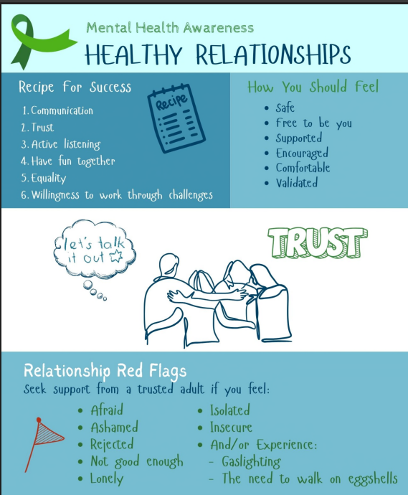
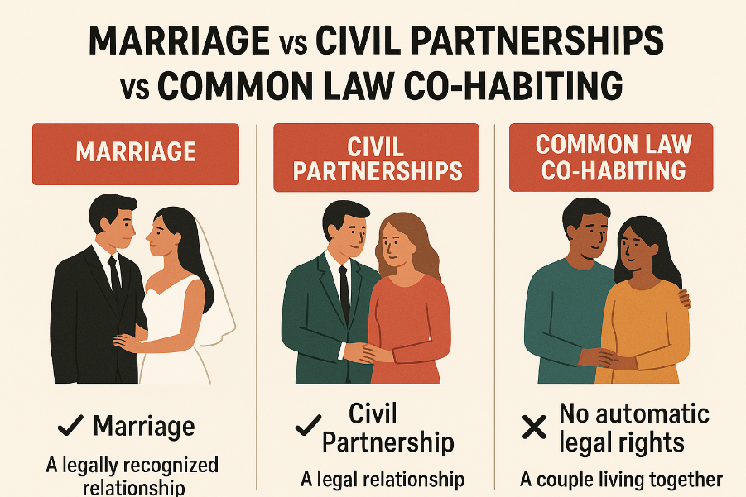
Sources of Support
Speak to a parent, tutor, head of year or trusted member of staff
NHS Sexual Health Services: https://www.nhs.uk/nhs-services/sexual-health-services
Family Lives: https://www.familylives.org.uk
Brook: www.brook.org.uk 0808 802 1234
Childline: www.childline.org.uk

Date: ___________________________
Lesson 1: How can you manage conflict in relationships?
Bell Task

On your whiteboards: What are the features of committed relationships?

Task 1:

Discuss this quote with your partner using the prompts on the board to help you. What’s your view?
______________________________________________________________________________
______________________________________________________________________________
______________________________________________________________________________
______________________________________________________________________________
______________________________________________________________________________
______________________________________________________________________________
______________________________________________________________________________
______________________________________________________________________________
______________________________________________________________________________
______________________________________________________________________________

Task 2: Carousel- share your thoughts in response to the statements

Task 3: Character profiles
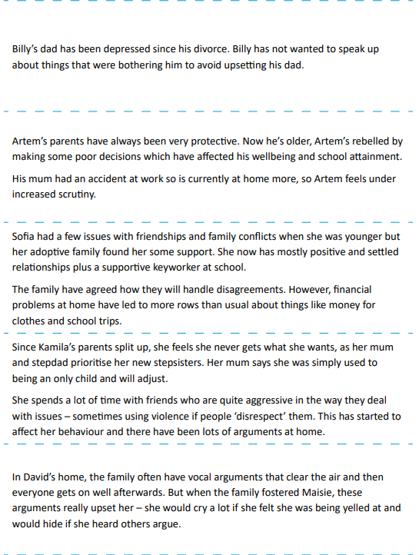

Task 4: De-escalation strategies
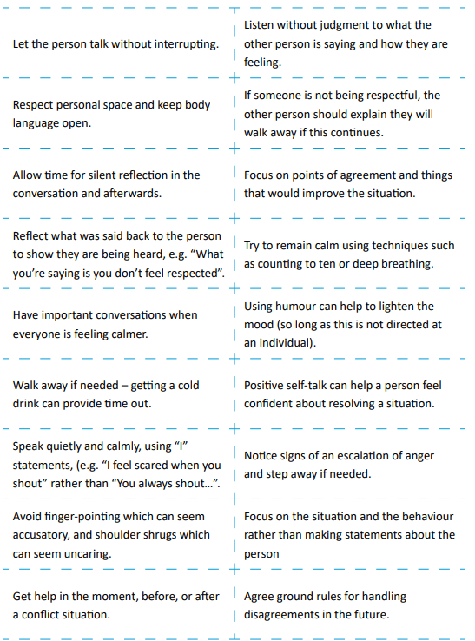

Task 5: Long term strategies
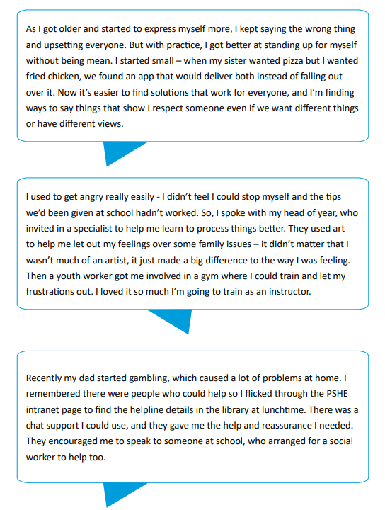

Reflection: State your top three strategies for managing conflict in relationships with others

1.
2.
3.
Date: ________________________

Lesson 2: What are the features of committed relationships?
Absent last lesson? Complete the while you were out questions below.
Use the knowledge organiser to answer the following questions:
- Name three features of healthy relationships

- Name three strategies that can be used to de-escalate conflict
Absent Last Lesson? Complete the ‘While You Were Out’ Task below.

Baseline

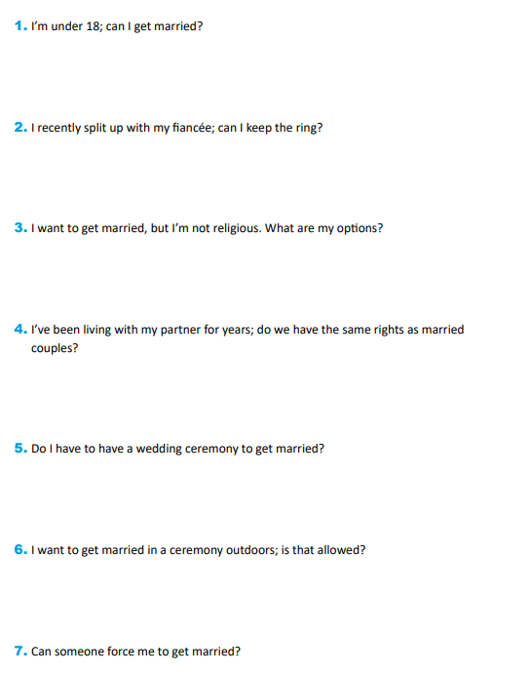
Task 1: Is the scenario legal or illegal? Explain your answer
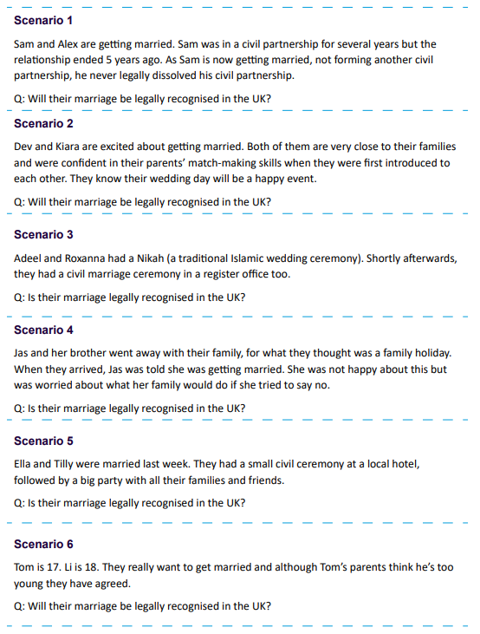

Task 2: Complete the lists below using the thought bubbles on the board

Reasons why people choose to get married or enter a civil partnership:

Reasons why people choose not to get married or enter a civil partnership:

Reflection: On your whiteboard, give your view on the statement below.

Getting married is the most important way you can show your commitment in a relationship.

Date:_____________________________
Lesson 3: What do I need to know about sexual health and parenthood?
Absent Last Lesson? Complete the ‘While You Were Out’ Task below.
Use the knowledge organiser to answer the following questions:
- What age can you get married in the UK?

- What legal rights do couples have that live together?

Baseline: What can you remember from last year?

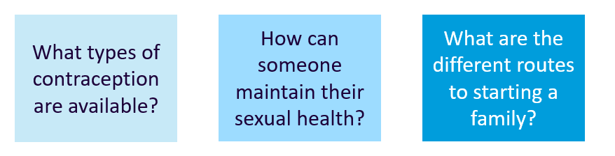

Task 2
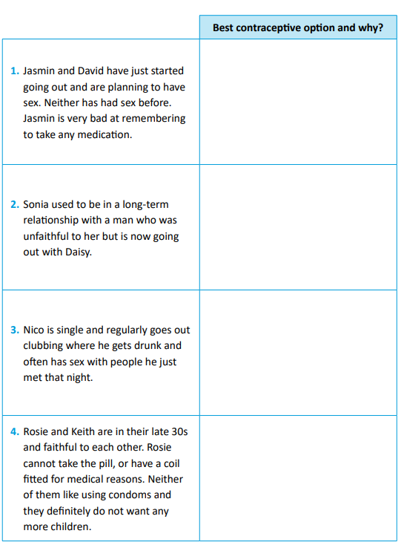

Task 3: Use the information on the board to help you.

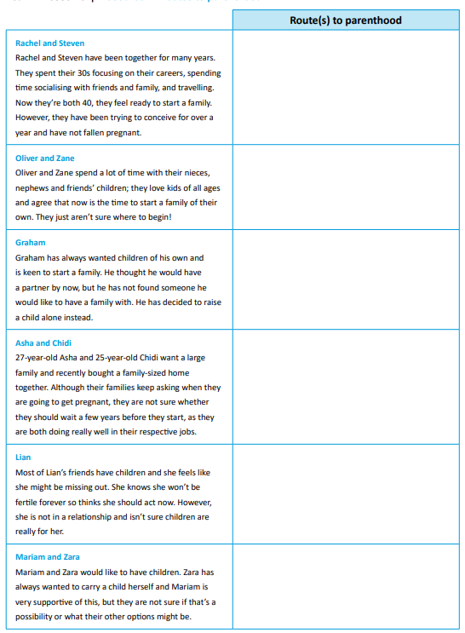

Reflection

Return to the bell task, what could you add in green pen?

Date:________________________________
Lesson 4: What choices are there for unplanned pregnancies?
Absent Last Lesson? Complete the ‘While You Were Out’ Task below.
Use the knowledge organiser to answer the following questions:
- What are committed relationships?

- What is IVF?

Baseline:

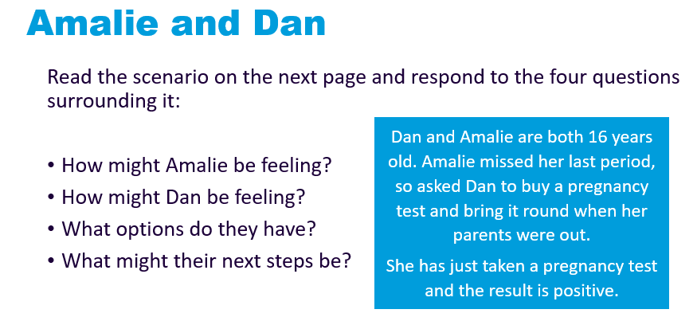

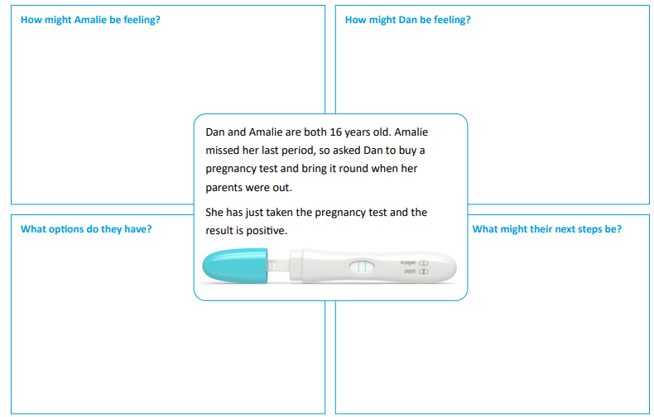

Task 1
In your pairs, read the scenario you have been given.
Your character has just discovered they are (or their partner is) pregnant – the pregnancy in each case was not planned.
As a group, discuss and write down your answers to the following questions:
1. What might your character’s initial reaction to the pregnancy be?
2. What might influence the character’s decision going forward?
3. Which influence might your character prioritise above all others?
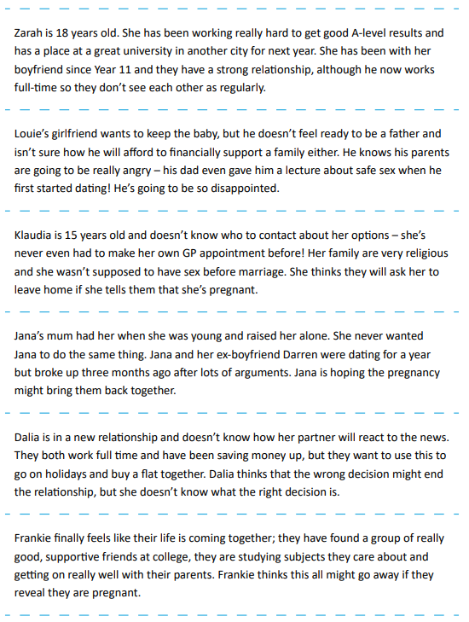
______________________________________________________________________________________________________________________________________________________________________________________________________________________________________________________________________________________________________________________________________________________________________________________________________________________________________________________________________________________________________________________________________________________________________________________________________________________________________________________________________________________________________________________________________________________________________________________________________________________________________________________________________________

For your scenario, plan a three step action plan (who to talk to, conversations they may have, where to find advice and guidance?
1.
2.
3.

Reflection

What advice would you give Dan and Amalie from our baseline task?

Date:________________________________
Lesson 5: Understanding abortion
Absent Last Lesson? Complete the ‘While You Were Out’ Task below.
Use information on the knowledge organisers and the previous pages to answer the following questions:
- What in an unplanned pregnancy?

- Identify two things that could influence decisions about an unplanned pregnancy?

Baseline


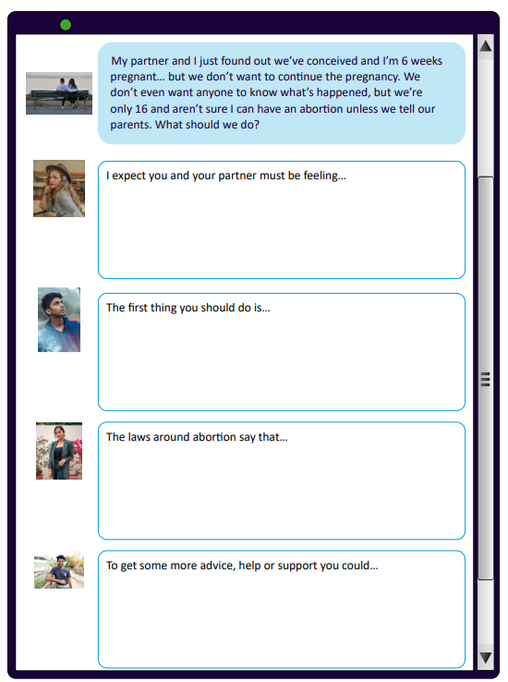

Task 1: Which 3 things do you think the original poster should know?
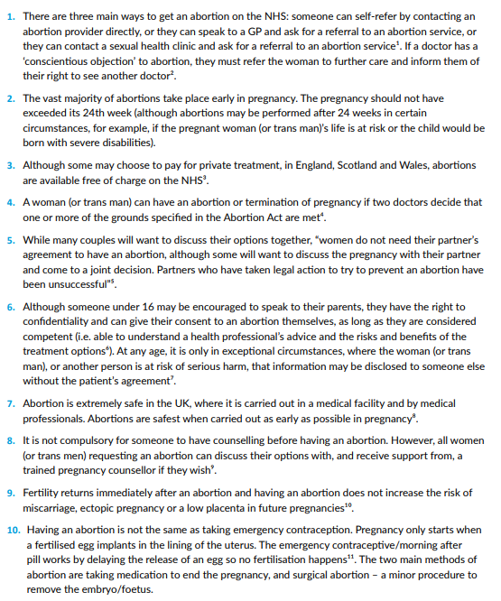

Task 2
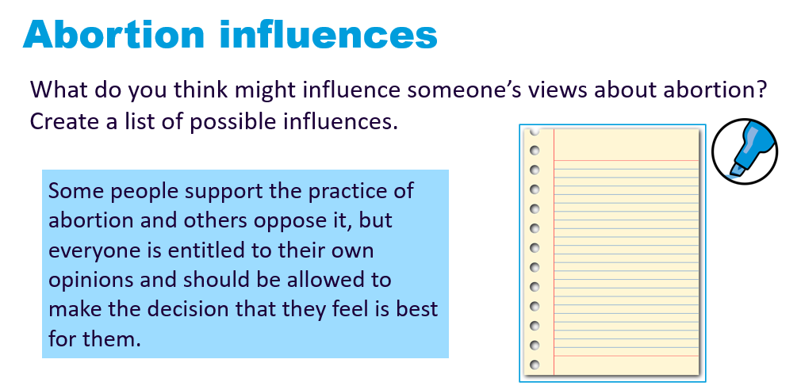

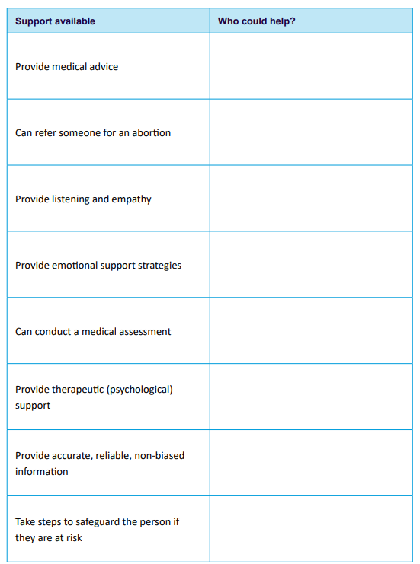
Reflection

Return to the baseline task. What could you add in now?
Assessment

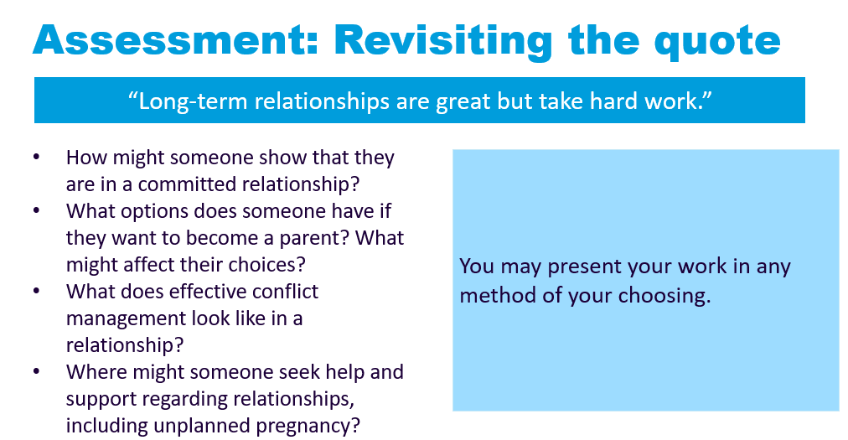

DIRT:
Have you included? | Highlight
Key topics covered this term such as: different types of relationships, legal rights, contraception, different pathways to having a family, unplanned pregnancy, pregnancy options.
Support and strategies to manage conflict in different types of relationships.
Which sources of support and advice are available?

All resources taken and adapted from PSHE Association

